SIMATS ENGINEERING

ASSESSMENT TOOL 1

COURSE CODE: CSA1402 COURSE NAME: COMPILER DESIGN

COURSE OUTCOME COVERED
CO3: Analyze syntax-directed translation method using synthesized and inherited attributes to generate a Parser Tree. (BL4)

Assessment Tool Weightage: 40%

QUESTIONS:5 Total Marks:100
Annexure A

EXPERIMENTS

Code of Conduct:
I V.VANDHANA VARSHA(192524265)(Name / Reg No) certify that this submission is my original work and that I have adhered to the guidelines specified for this assessment.
I understand that any violation of academic integrity rules will result in disciplinary action.

Signature of the student:

V.VANDHANA VARSHA
Annexure A

EXPERIMENTS

Q1.You are developing a compiler-based desk calculator that evaluates arithmetic expressions using syntax-directed definitions (SDD).
The system should:
- Accept an arithmetic expression with operators +, -, *, / and parentheses
- Use syntax-directed evaluation to compute values based on operator precedence
- Optimize evaluation by reducing unnecessary temporary computations
- Display the final result of the expression
Demonstrate how SDD rules (synthesized attributes) are used for expression evaluation. SDD
Grammar with semantic rules:
E → E + T { E.val = E1.val + T.val } E → E - T { E.val = E1.val - T.val } E → T { E.val = T.val }

T → T * F { T.val = T1.val * F.val } T → T / F { T.val = T1.val / F.val } T → F { T.val = F.val }

F → (E) { F.val = E.val } F → digit { F.val = digit }

Aim

To evaluate arithmetic expressions using Syntax-Directed Definition (SDD) and synthesized attributes.
Theory

SDD associates semantic rules with grammar productions. The val attribute is synthesized from the child nodes.
The grammar separates:
- E → Expression
- T → Term
- F → Factor
This ensures * and / have higher precedence than + and -.
Example
For:
2 + 3 * 4
Evaluation:
3 * 4 = 12
2 + 12 = 14
Therefore:
E.val = 14
Optimization

Intermediate values are directly passed between E, T, and F, reducing unnecessary temporary computations.
Result

Thus, the arithmetic expression is successfully evaluated using SDD and synthesized attributes.

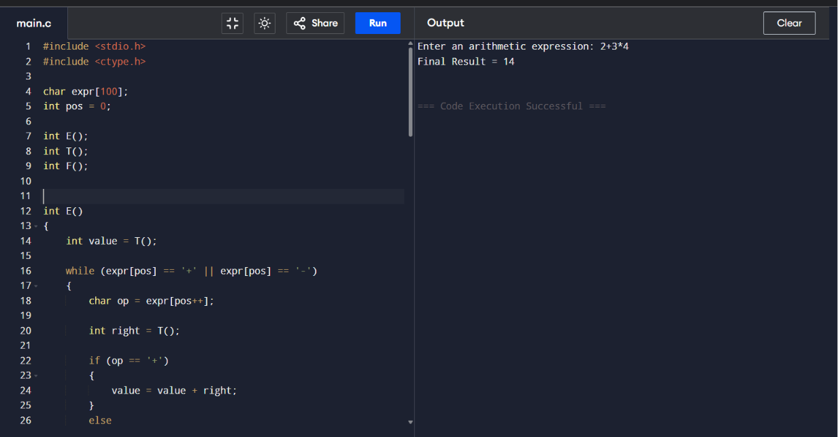

Q2. In a compiler, postfix expressions are evaluated during code generation using stack-based bottom-up evaluation.
Write a C program that:
Evaluates a postfix expression
Demonstrates S-attributed definition evaluation
Shows how intermediate results are computed

Aim
To evaluate a postfix expression using a stack and demonstrate S-attributed evaluation.
Theory
In postfix evaluation, operands are pushed onto a stack. When an operator is encountered, operands are popped, the operation is performed, and the result is pushed back.

Example
Postfix: 234*+
Evaluation:
3 * 4 = 12
2 + 12 = 14
Final result:
14

S-Attributed Evaluation
The intermediate result is synthesized from the operand values and passed upward for further computation.

Result
Thus, the postfix expression is successfully evaluated using stack-based bottom-up evaluation and S-attributed definition.

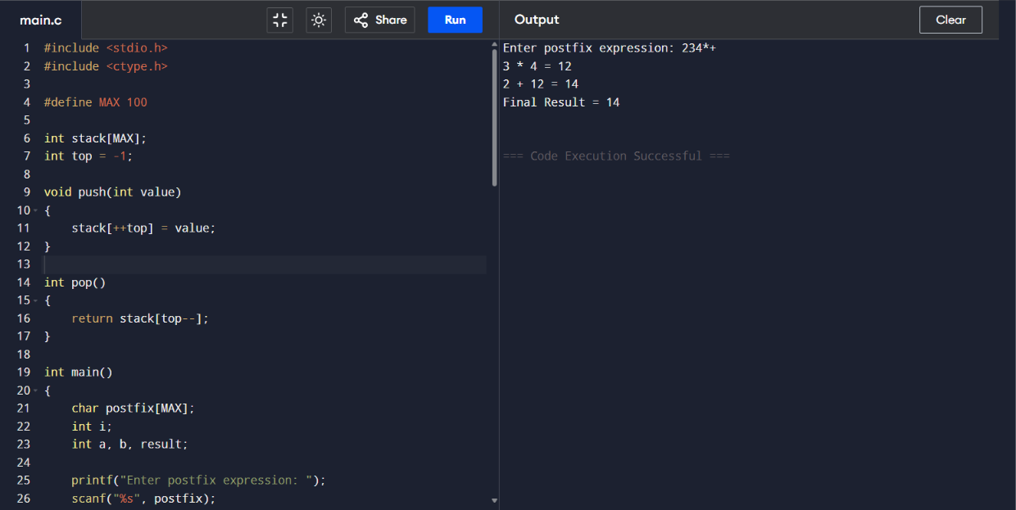
Q3.You are designing a parser that uses L-attributed definitions, where inherited attributes are passed from parent to child.
Write a C program that:
(i).Evaluates a simple expression like a + b * c
(ii) Uses function parameters to simulate inherited attributes
Ensures correct precedence handling
Demonstrates top-down evaluation logic
Explain how inherited attributes influence computation.

Aim
To evaluate an expression using L-attributed definitions and function parameters to simulate inherited attributes.

Theory
In L-attributed definitions, information can be passed from a parent to its child. In C, function parameters can be used to simulate this flow of information.

Example
For:
a + b * c
If:
a = 2
b = 3
c = 4
Evaluation:
b * c = 3 * 4 = 12
a + 12 = 14

Inherited Attributes
Values are passed as function parameters from one evaluation level to another, representing inherited information.

Precedence
The grammar evaluates multiplication before addition, ensuring correct operator precedence.

Result
Thus, the expression is successfully evaluated using L-attributed evaluation and inherited attributes.
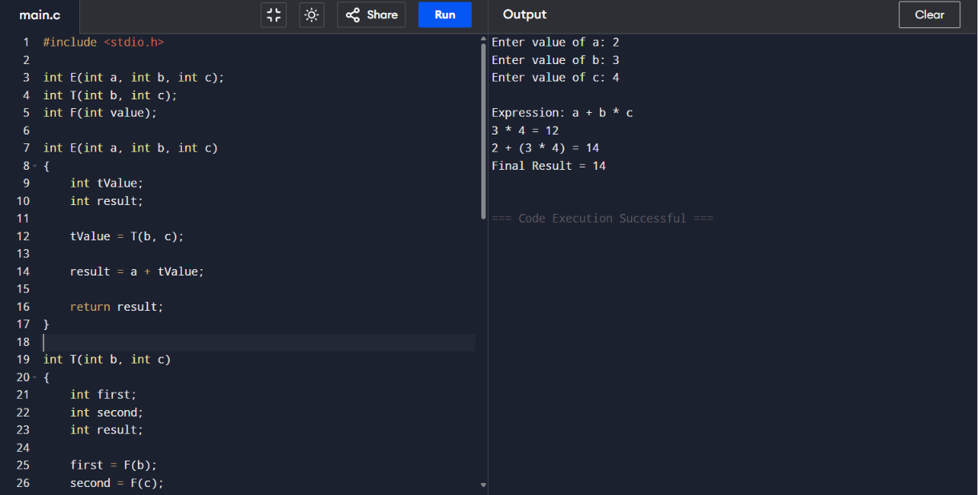

Q4.In a compiler, it is important to check whether two type expressions are equivalent. Write a C program that:
(i).Accepts two type expressions (e.g., int, float, int*) (ii).Compares them for type equivalence
(iii).Displays whether they are:
(a).Equivalent (b).Not equivalent
Extend the logic to handle pointer types (int*, float*).

Aim
To compare two type expressions and determine whether they are equivalent.

Theory
Type equivalence checks whether two type expressions represent the same type.

Examples:
int and int → Equivalent
int and float → Not Equivalent
int* and int* → Equivalent
int* and float* → Not Equivalent

Pointer Types
For pointer types, both the pointer and its base type must match.

For example:
int* ≠ float*
because their base types are different.

Result
Thus, the program successfully checks equivalence between basic and pointer types.

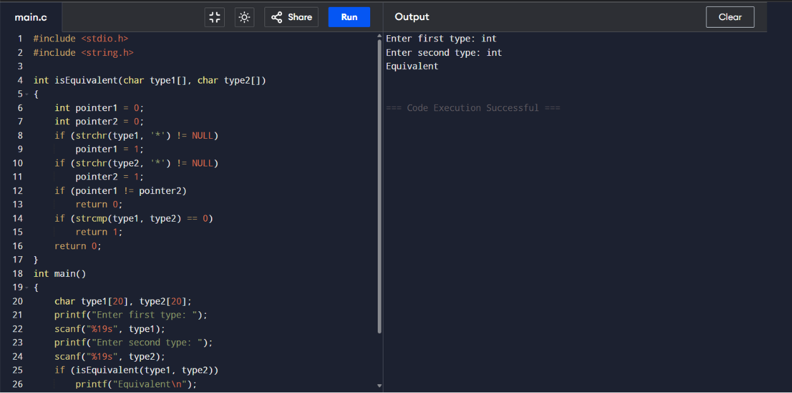

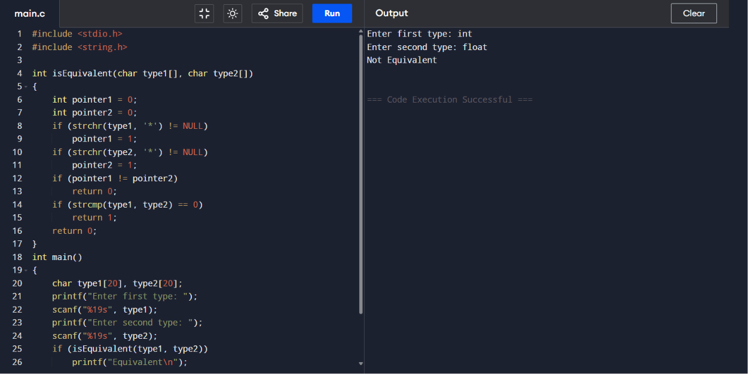

Q5.You are building a semantic analyzer that detects type errors in arithmetic expressions. Write a C program that:
Accepts two operands and their types
Checks whether the operation (e.g., +, *) is valid
Reports:
(a).Valid expression
(b).Type error (e.g., int + char*)
Demonstrate how compilers detect semantic errors during type checking

Aim
To check whether an arithmetic operation is valid based on the types of its operands.

Theory
Type checking is performed during semantic analysis. It verifies whether operands are compatible with the given operator.

Examples:
int + int → Valid expression
int + float → Valid expression
int + char* → Type error
int * int* → Type error

Type Checking
The semantic analyzer checks the types of both operands before allowing the operation.
For example:
int + char*
is invalid because the operands are incompatible.

Result
Thus, the program successfully performs semantic type checking and identifies valid expressions and type errors.

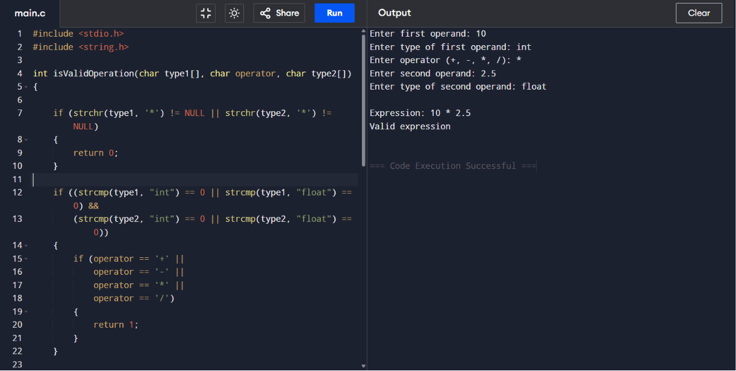

RUBRICS FOR CALCULATION

Criteria | Weightage | Level 4 – Exemplary | Level 3 – Proficient | Level 2 – Developing | Level 1 – Beginning
Understanding of Concepts | 25 | Demonstrates thorough understanding and effectively integrates multiple concepts/technologie  s | Good understanding with proper integration of most concepts | Basic understanding; limited or partial integration | Poor understanding; unable to integrate concepts
Experimental Design | 30 | Well-planned, systematic implementation with optimal solution | Correct implementation with minor issues | Basic implementation with errors or inefficiencies | Incorrect or incomplete implementation
Use of Tools | 20 | Effective and advanced use of tools/technologies with proper configuration | Appropriate use of tools with correct execution | Limited or inconsistent use of tools | Incorrect or minimal use of tools
Analysis of Results | 15 | Insightful analysis with accurate interpretation and validation of results | Good analysis with reasonable interpretation | Basic analysis with limited insights | Poor or incorrect analysis of results
Documentatio n | 10 | Clear, well-structured documentation with diagrams, code, and results | Organized documentation with necessary details | Basic documentation with missing details | Poor or incomplete documentation

